**SQL Aggregate Functions in SQL*Plus (Oracle) & MySQL**

Aggregate functions perform calculations on multiple rows and return a **single** value. These functions are useful in **summarizing** data, such as totals, averages, counts, etc.

Below are detailed examples covering all aggregate functions in **SQL*Plus (Oracle)** and **MySQL**.

**1. Aggregate Functions in SQL*Plus (Oracle) 1.1 SUM() – Total of a Column**

SELECT SUM(salary) AS total_salary FROM employees; -- Total salary of all employees

SELECT department_id, SUM(salary) FROM employees GROUP BY department_id; -- Total salary per department 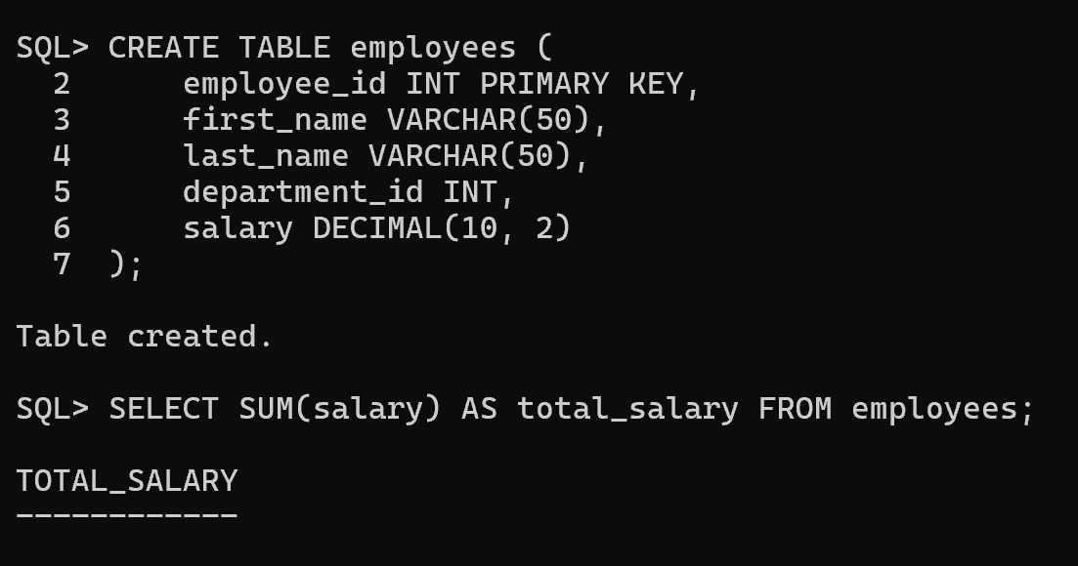

**1.2 AVG() – Average of a Column**

SELECT AVG(salary) AS avg_salary FROM employees; -- Average salary SELECT department_id, AVG(salary) FROM employees GROUP BY department_id; -- Average salary per department 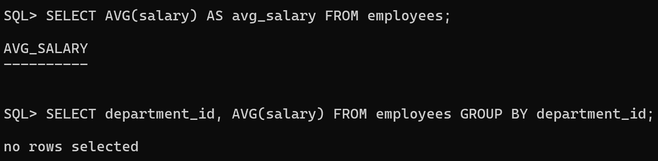

**1.3 COUNT() – Counting Rows**

SELECT COUNT(*) FROM employees; -- Total number of employees SELECT COUNT(employee_id) FROM employees WHERE department_id = 10; -- Count employees in department 10

SELECT department_id, COUNT(*) FROM employees GROUP BY department_id; -- Count per department 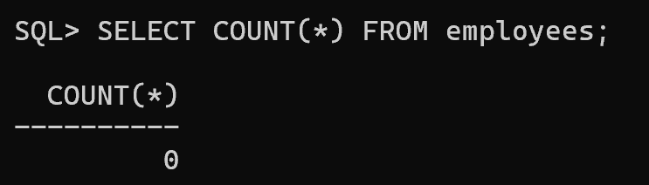

**1.4 MAX() – Maximum Value**

SELECT MAX(salary) FROM employees; -- Highest salary in the company SELECT department_id, MAX(salary) FROM employees GROUP BY department_id; -- Highest salary per department 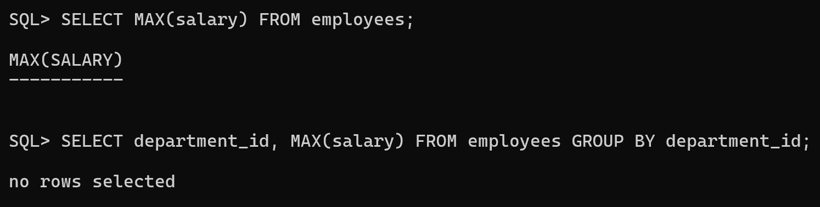

**1.5 MIN() – Minimum Value**

SELECT MIN(salary) FROM employees; -- Lowest salary in the company SELECT department_id, MIN(salary) FROM employees GROUP BY department_id; -- Lowest salary per department 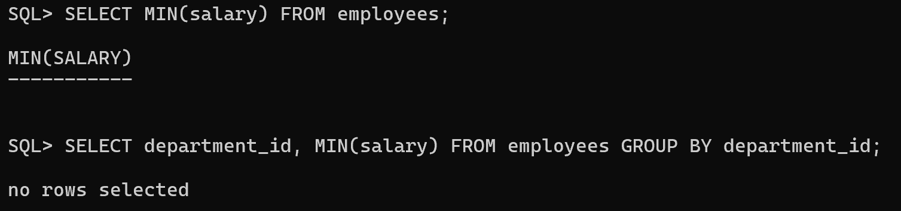

**1.6 MEDIAN() – Median Value (Oracle-Only)**

SELECT MEDIAN(salary) FROM employees; -- Median salary of all employees 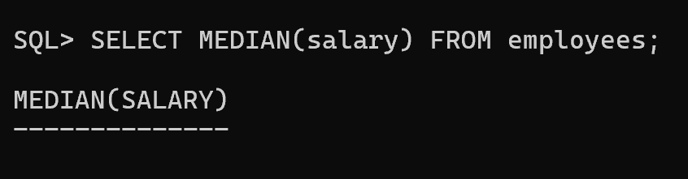

**1.7 STDDEV() – Standard Deviation**

SELECT STDDEV(salary) FROM employees; -- Standard deviation of salaries

SELECT department_id, STDDEV(salary) FROM employees GROUP BY department_id; -- Std deviation per department 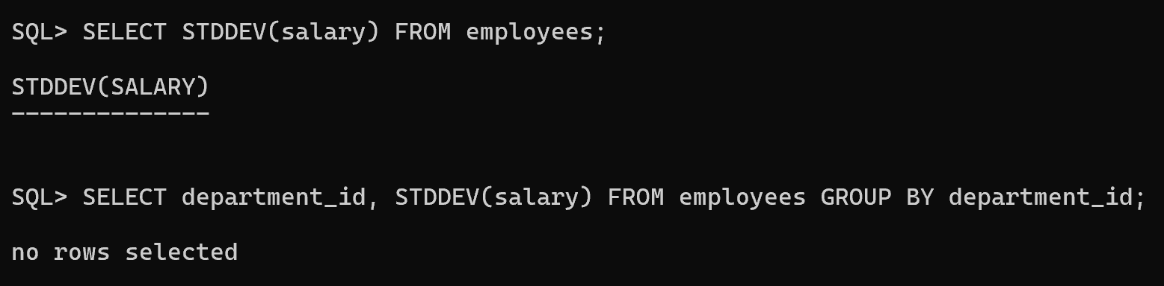

**1.8 VARIANCE() – Variance of a Column**

SELECT VARIANCE(salary) FROM employees; -- Variance of salaries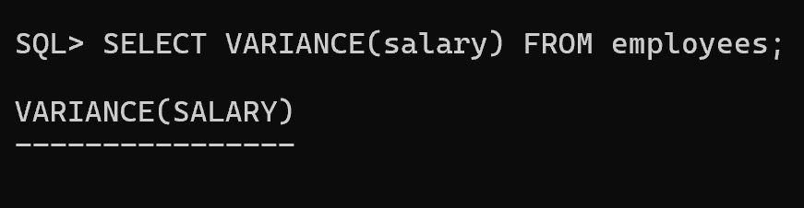

**1.9 GROUP BY with Aggregate Functions**

SELECT department_id, COUNT(*), AVG(salary), MAX(salary), MIN(salary) FROM employees

GROUP BY department_id; -- Aggregate calculations per department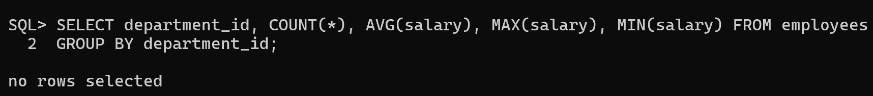 **1.10 HAVING Clause (Filtering Groups)**

SELECT department_id, COUNT(*) AS employee_count

FROM employees

GROUP BY department_id

HAVING COUNT(*) > 5; -- Only departments with more than 5 employees 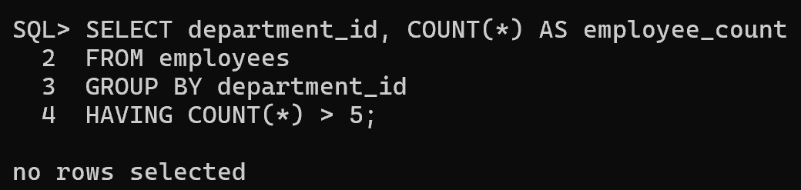

**2. Aggregate Functions in MySQL**

**2.1 SUM() – Total of a Column**

SELECT SUM(salary) AS total_salary FROM employees; -- Total salary of all employees

SELECT department_id, SUM(salary) FROM employees GROUP BY department_id; -- Total salary per department

**2.2 AVG() – Average of a Column**

SELECT AVG(salary) AS avg_salary FROM employees; -- Average salary SELECT department_id, AVG(salary) FROM employees GROUP BY department_id; -- Average salary per department

**2.3 COUNT() – Counting Rows**

SELECT COUNT(*) FROM employees; -- Total number of employees SELECT COUNT(employee_id) FROM employees WHERE department_id = 10; -- Count employees in department 10

SELECT department_id, COUNT(*) FROM employees GROUP BY department_id; -- Count per department

**2.4 MAX() – Maximum Value**

SELECT MAX(salary) FROM employees; -- Highest salary in the company SELECT department_id, MAX(salary) FROM employees GROUP BY department_id; -- Highest salary per department

**2.5 MIN() – Minimum Value**

SELECT MIN(salary) FROM employees; -- Lowest salary in the company SELECT department_id, MIN(salary) FROM employees GROUP BY department_id; -- Lowest salary per department

**2.6 STDDEV() – Standard Deviation**

SELECT STDDEV(salary) FROM employees; -- Standard deviation of salaries

SELECT department_id, STDDEV(salary) FROM employees GROUP BY department_id; -- Std deviation per department

**2.7 VARIANCE() – Variance of a Column**

SELECT VARIANCE(salary) FROM employees; -- Variance of salaries

**2.8 GROUP BY with Aggregate Functions**

SELECT department_id, COUNT(*), AVG(salary), MAX(salary), MIN(salary) FROM employees

GROUP BY department_id; -- Aggregate calculations per department **2.9 HAVING Clause (Filtering Groups)**

SELECT department_id, COUNT(*) AS employee_count

FROM employees

GROUP BY department_id

HAVING COUNT(*) > 5; -- Only departments with more than 5 employees

**3. Key Differences Between SQL*Plus (Oracle) and MySQL Aggregate Functions**

|  |  |  |
| --- | --- | --- |
| **Feature** | **Oracle (SQL*Plus)** | **MySQL** |
| Basic Aggregate  Functions | SUM(), AVG(), COUNT(),  MAX(), MIN() | SUM(), AVG(), COUNT(),  MAX(), MIN() |
| Median Calculation | MEDIAN() | Not available (requires  workaround) |
| Standard Deviation | STDDEV() | STDDEV() |
| Variance Calculation | VARIANCE() | VARIANCE() |
| Handling NULL  values | Ignores NULL values in  aggregate functions | Ignores NULL values in  aggregate functions |
| HAVING Clause  GROUP BY | Used after GROUP BY  Used to group and aggregate | Used after GROUP BY  Used to group and aggregate |

**4. Special Notes**

● **Oracle** provides the **MEDIAN()** function, but **MySQL does not**. In MySQL, median must be calculated using a workaround.

● **Both** ignore NULL values when computing aggregates unless explicitly handled. ● **HAVING** is used **after GROUP BY** to filter aggregated results in both Oracle and MySQL.